

***Dear Dr.,Mr., Mrs.,(…)***

Invitation to discuss and celebrate the certification of the Food-Safety Trainings with and for Street food Vendors, which are part of the pilot project “Sustainable Street Food Plan” – reaching for a sustainable development of the Street Food sector in the Megacity of Hyderabad

Indo-German Project Sustainable Hyderabad, University of Goettingen and Dr. Reddy’s Foundation, invite to the **Certification event**

19th January 2013, 11.00am - 2pm, Cooperative Office “Arogya”,

opp. lane to RS Brothers Shapur Nagar, Jeedimetla

Program Certification Ceremony:

**11:00 – 11.15 Opening**

**11.15 – 11.30 Why this program? – Importance of Trainings**

**11.30 – 12.00 Address Food-Safety Experts**

**12.00 – 12.40 Sharing of Experience – Food-Safety Trainers**

**12.40 – 01.00 Tea break**

**01.00 – 01.40 Distribution of Certificates by Experts and Project Team**

**01.40 – 02.00 Closing**

Modern city development and food culture

For the vast majority of Hyderabadis, traditional small retailers and street food vendors are still an essential source of food provision. Moreover, street foods are an integral part of urban life in Hyderabad.

The potentials and advantages of these services are as obvious as are the challenges and deficits, the ones they create and the ones they face every day.

How to compass sustainable street food?

The challenges are to make this decentralized, energy-efficient, climate-friendly and socially desirable food retailing system part of the modern urban development by equipping street food vendors with knowledge and skills needed to serve affordable, healthy and hygienic food.

As part of the pilot project “Sustainable Street Food Plan” the Sustainable Hyderabad Project/University of Goettingen in cooperation with the Dr. Reddy’s Foundation has conducted a pilot program to enable Street Food Vendors to become Street Food-Safety Trainers.

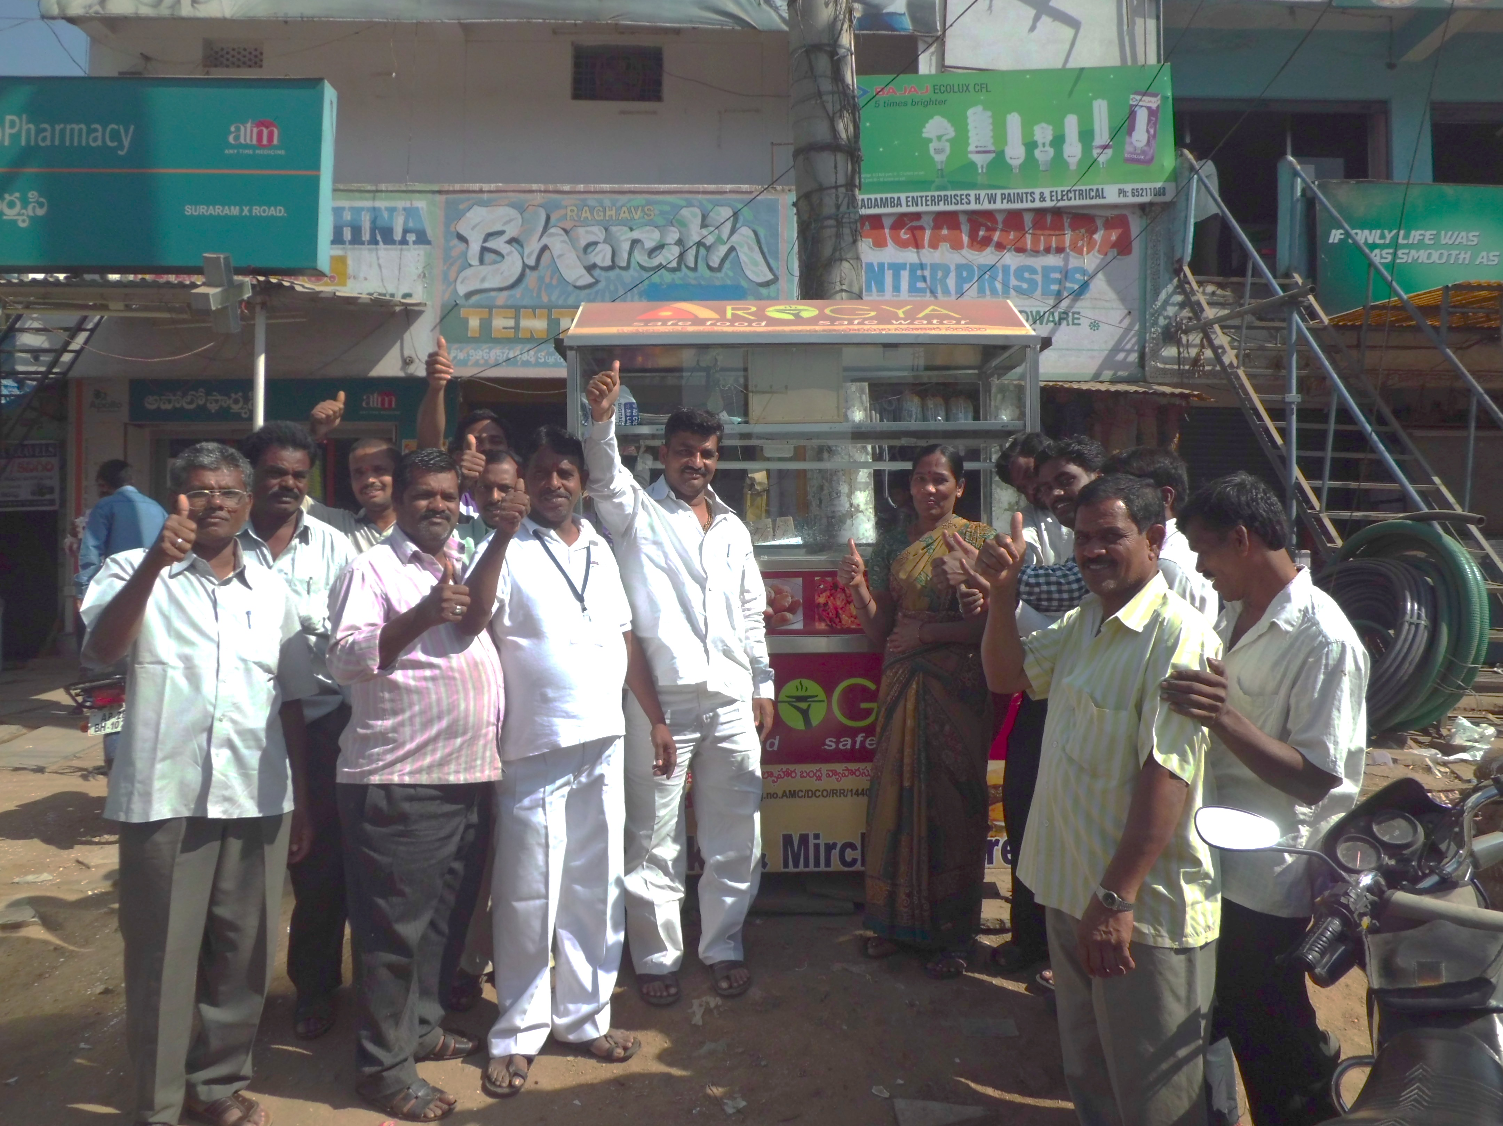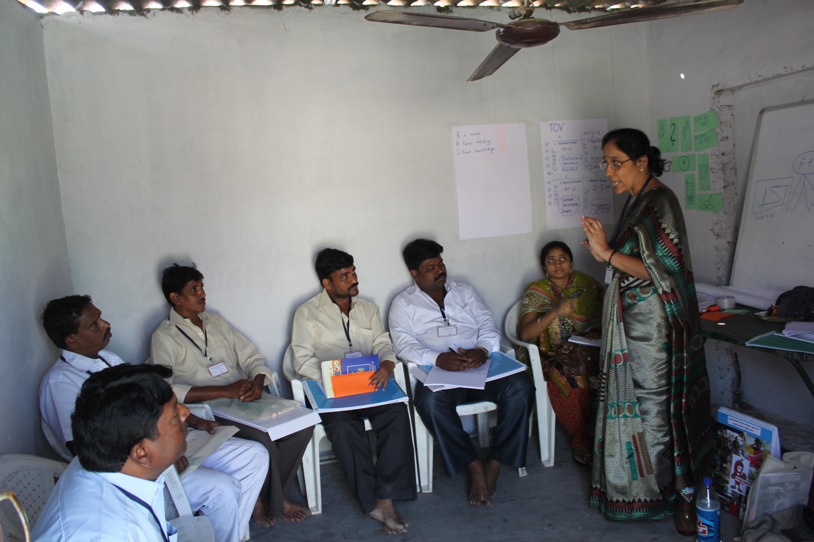

A wide spread belief – not true as many studies have shown – is that Street Food is lacking of hygiene, which influenced the bad public image of Street Food Vendors for many years.

Food-Safety is one essential issue to be tackled!

Street Food Vendors have the obligation to work according to the Food Safety and Standards Act (FSSA 2006), it is the obligation of the governmental authorities to raise awareness and build capacities to enable the vendors to follow the act consciously.

**Enable Street Vendors to become Food-Safety Trainers!**

In a pilot approach, four Street Food Vendors have been trained to become Food-Safety Trainers, again to train other vendors. Also experts of NIN, Home Science College and Institute of Preventive Medicine have given professional input and informed about nutrition, hygiene and food safety and standart. After completing 6 days training, these trainers were able to train four days 79 street vendors, divided into four batches and items of Chaat, Mirchi, Chinese Fast Foot and Tiffins in the area of Jeedimetla.

*The certification ceremony will be held in Jeedimetla. Beside hand over of certification, trainers, experts and the SHP-Team will inform about the program and share experiences. We want to appreciate the work of the vendors-trainers, experts and those who have made this program possible.*

*We herewith invite you to participate on our event and hopefully we will have the great opportunity to meet you in Jeedimetla.*

*Best,*

*Anne Dahmen, Project Coordinator*

Street Food Safety Trainings:

Certification Event